**Seminar 1 Report**

Wang XingYi 2226215258

# Topic

There are two topics to be presented. Topic 1 requires us to give an illustration of one daily power electronic equipment, including its function as well as input and output features. Then we should differentiate and mark down different parts of the circuit. The component used in this device and its parameters are also to be reported.

For Topic 2, we are supposed to simulate several characteristics of IKW15T120, an assigned IGBT device, in LTspice. The comparison between simulation results and characteristics given by the datasheet is also required.

**Considering that Topic 1 does not contain any specific simulation process, I shall first report on Topic 1 in the following part (Chapter 1.2).**

## *1.2 Topic 1: Induction Cooker produced by Midea*

We choose a prevalent induction cooker as the main equipment for this topic. The specific type of this cooker is C21-ST2106.

The beauty of induction cooking is that the heat is generated within the cookware. There will be no heat generated without the cookware on the top of the coil. What is more, you can adjust the size of power based on different modes given by the cooker. All you need is to touch the switching button. Thus, the induction cooker is quicker and highly energy efficient compared to other conventional methods. Besides, it is safer because the open flame is avoided during cooking.

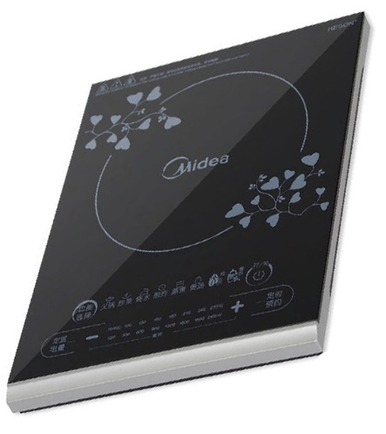

Fig 1 C21-ST2106

## *1.2.1 Function and Working Principle*

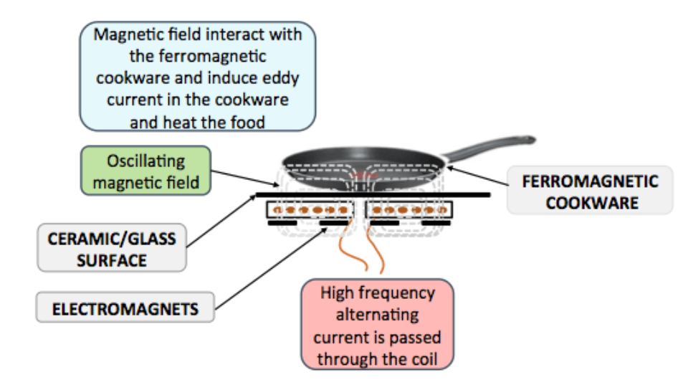

Fig 2 The working principle of an induction cooker

The core part of this cooker is a PWM switching power circuit. Briefly, through this section, we can acquire a PWM wave that will form a high-frequency oscillation with the resonant coil. With the high-frequency alternating current passing through the coil, we can generate an alternating magnetic field correspondingly, which will induce eddy current flowing through the cookware, thus generating the desired heat.

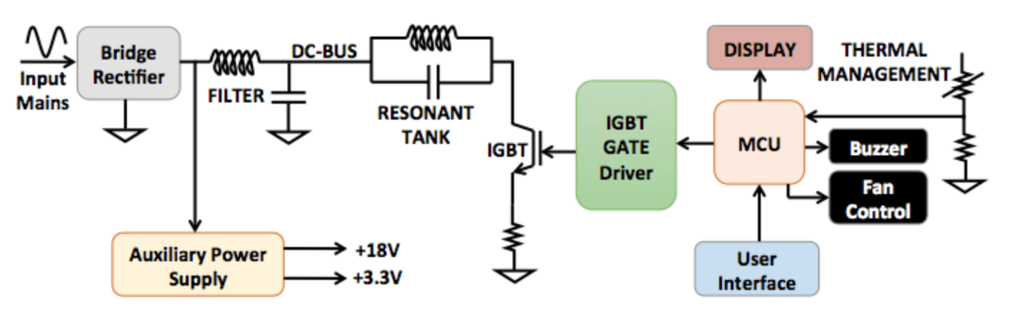

Fig 3 Blocking diagram of the circuit

## *1.2.2 Input and Output Features*

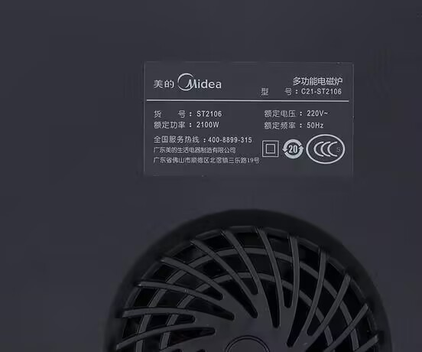

Fig 4 Input and output features of induction cooker produced by Midea

Rated Voltage: 220V

Rated Frequency: 50Hz

Rated Power: 2100W

## *1.2.3 Analysis of Circuit Diagram*

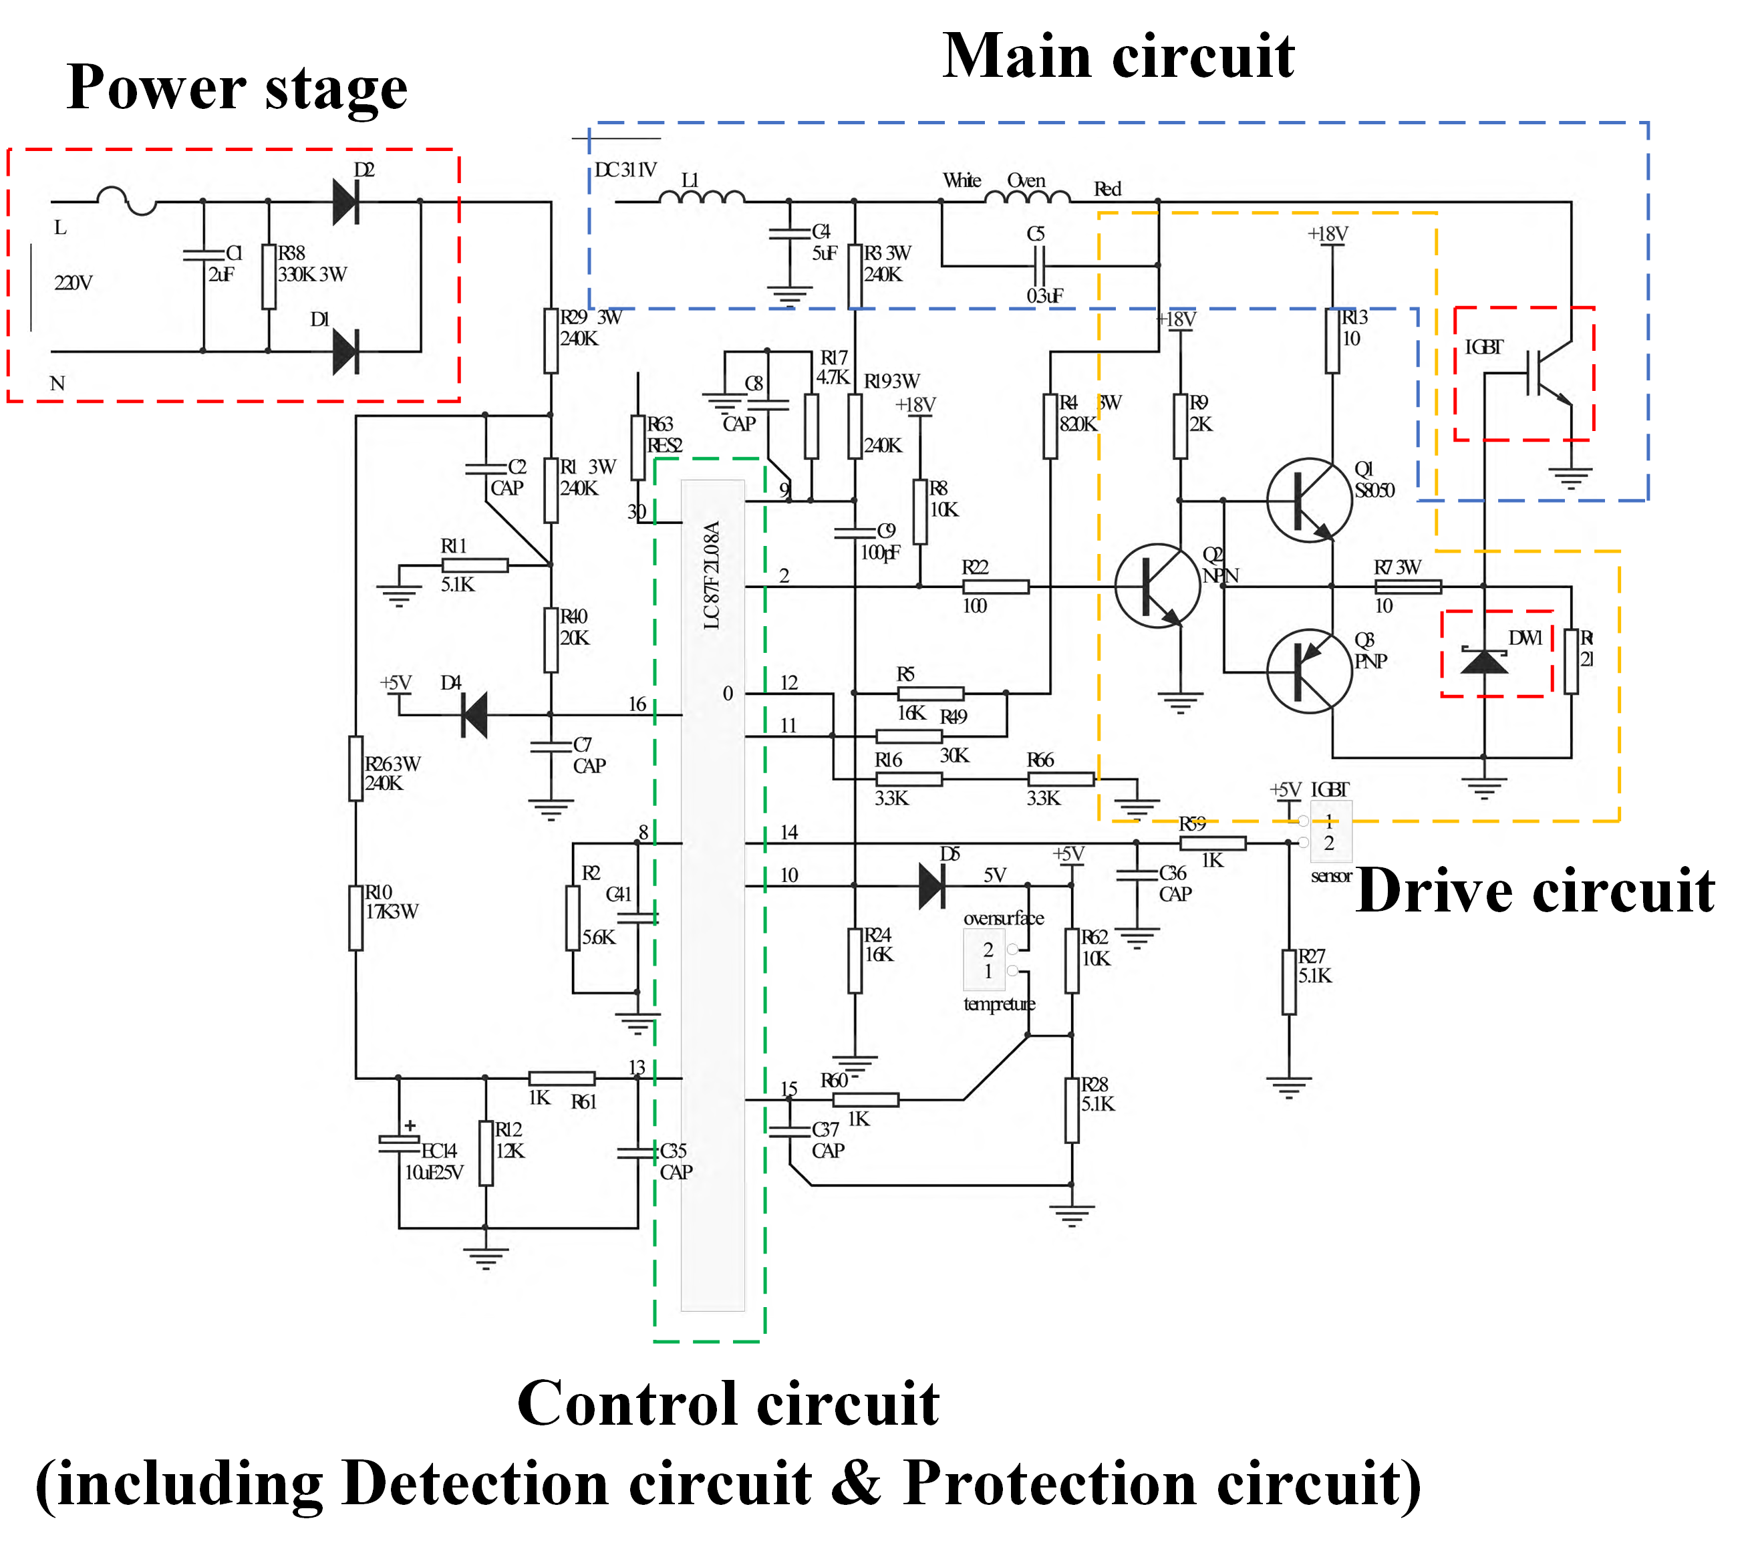

Fig 5 General circuit of the induction cooker

As what has been presented above, the whole circuit can be classified into three parts. In the power stage, the 220V Input alternating voltage goes through the rectifier bridge and filter to transfer into direct voltage. The IGBT in the drive circuit conducts the high-frequency pulse signals, which will form a high-frequency oscillation with the resonant coil of the main circuit.

The core of the control circuit is LC87F2L08A, which contains several functions.

1. The 9th pin of the LC87F2L08A microcontroller is used for synchronous control, which aims to keep the frequency of the pulse signal generated by the oscillation circuit the same as the frequency of the PWM signal. In other words, the Collector and Gate poles of the IGBT are at the same frequency. Changing the width of the pulse signal without changing the frequency is beneficial for the stability of the whole circuit.
2. The 10th pin receives the pot detection signal (DC voltage). The magnitude of the value reflects the input current of the power supply. The higher the voltage, the greater the heating power.
3. The 11th and 12th pins are combined to achieve the function of high voltage protection.
4. The thermistor installed above the IGBT has a resistance of 9 k Ω at room temperature. The 5V power supply voltage is divided by R17 and sent to pin 14 of the LC87F2L08A microcontroller. By monitoring the variation of the voltage, the CPU can calculate the temperature of IGBT.
5. The 15th pin is the input terminal of the integrated circuit, which plays a role in detecting the temperature at the bottom of the pot.
6. Due to the fact that the coil L1 and capacitor C4 can form a parallel resonant circuit, there is a possibility of generating overvoltage. To protect the integrated circuit, an alarm must be triggered when surge voltage occurs. The 16th pin of LC87F2L08A is used to monitor the surge situation of 220V AC power.

## *1.2.4 Dismantling Diagrams*

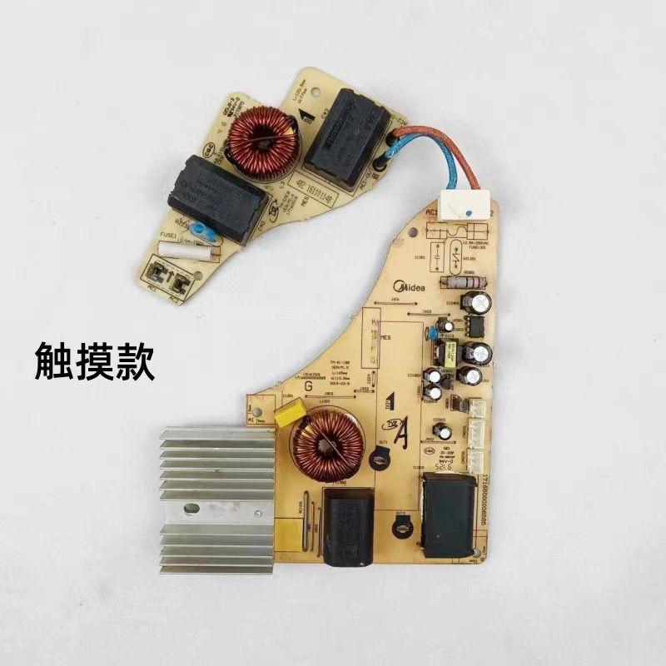 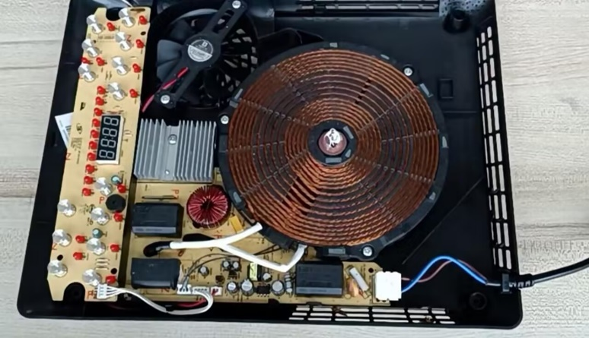

Fig 6 Main section of the cooker (L) Complete dismantling figure (R)

On the left side is the main circuit of the induction cooker. The equivalent circuit diagram can be found in Fig 5. Fig 6(R) shows what the device looks like removing the upper package. We can see the coil in the center area, which generates the alternating magnetic field.

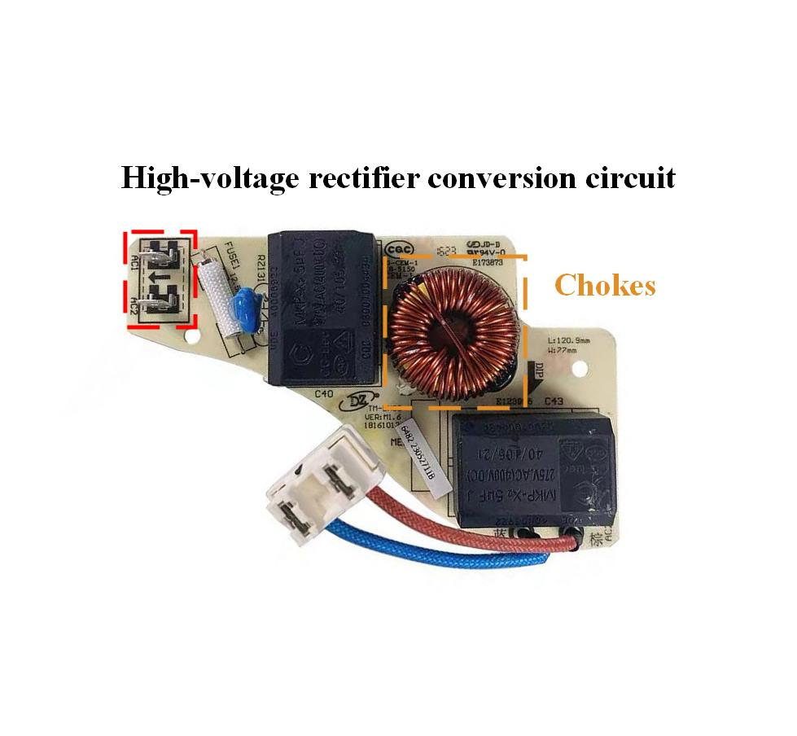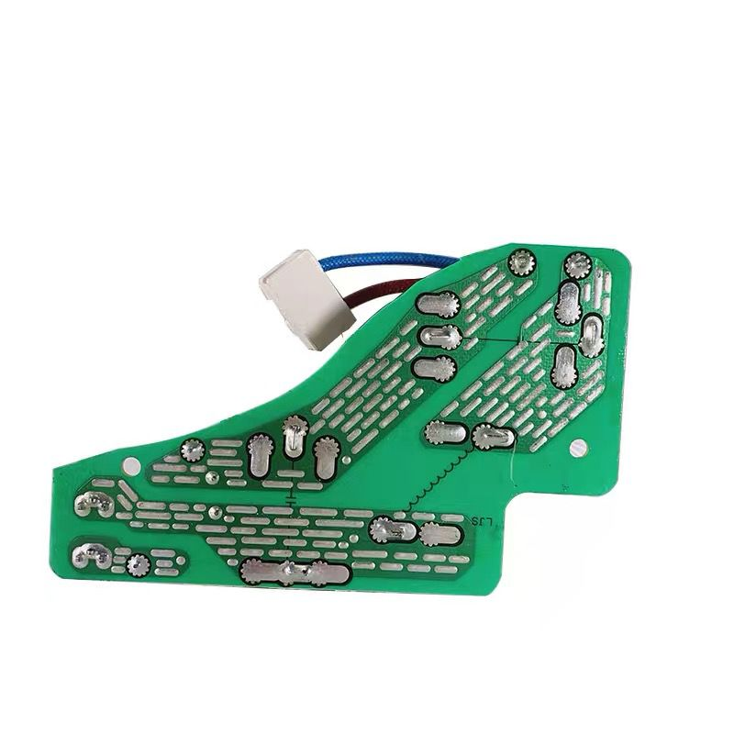

Fig 7 High-volt rectifier conversion circuit (L) back side of the PCB board (R)

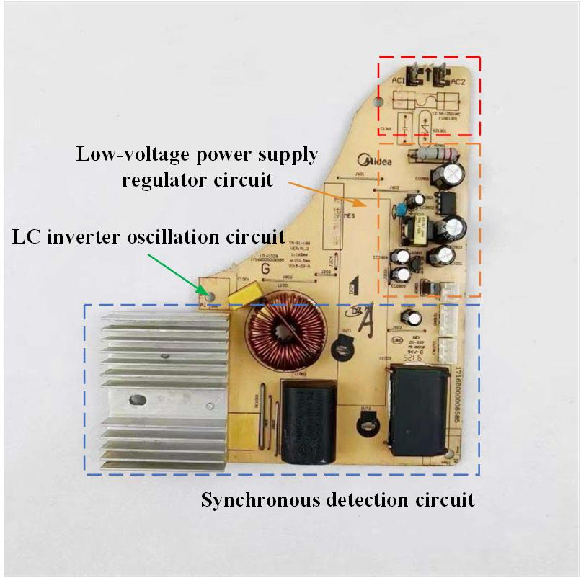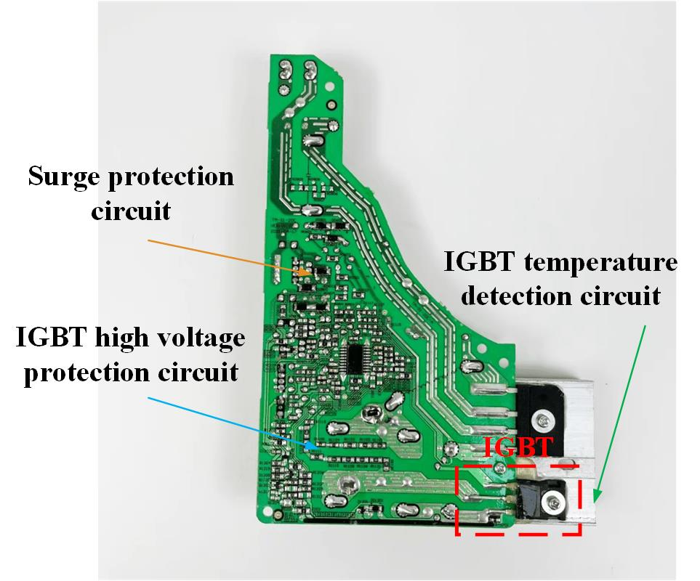

Fig 8 main functions of different sections (L) back side (R)

## *1.2.5 Component and Parameters*

We select the core part of the drive circuit—— IGBT as the component used in the circuit.

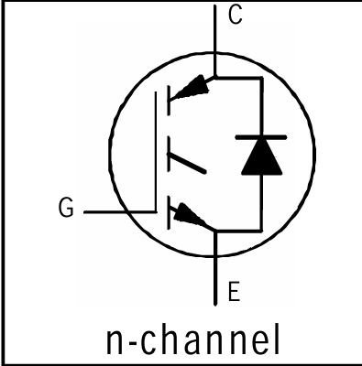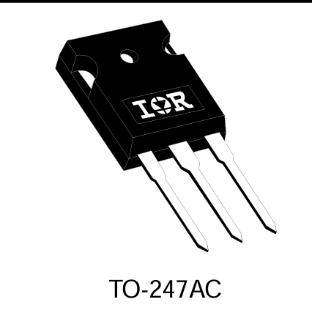

Fig 9 The model and type of driving IGBT

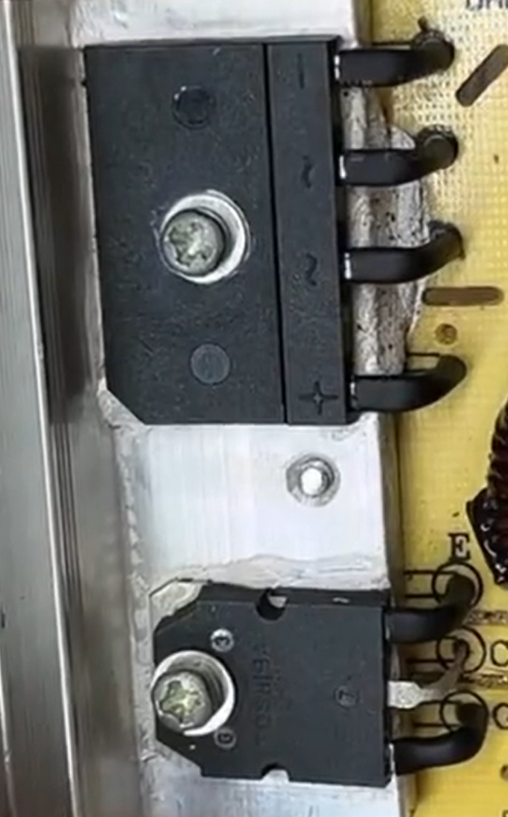

Fig 10 TO-247AC from the PCB

# Simulation Model

For topic 2, there are 4 characteristics to be specified about the IGBT device, and 2 models are established correspondingly.

## *2.1 Simulation Model 1*

This model is established to acquire the Output characteristics, Transfer characteristics and Switching waveform of IKW15T120.

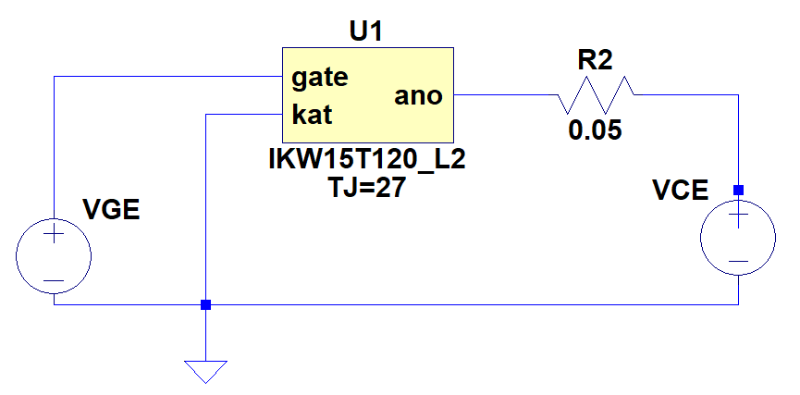

Fig 11 Simulation model 1

1. Output characteristics: The relationship between VCE (Collector-Emitter Voltage) and Ic (Collector Current) under different values of VGE(Gate-Emitter Voltage) is supposed to be explored.
2. Transfer characteristics: The relationship between VGE and Ic with fixed VCE under different Tj (Junction Temperature).
3. Switching characteristics: How VC and Ic vary with time given that VGE serves as a pulsating signal.

## *2.2 Simulation Model 2*

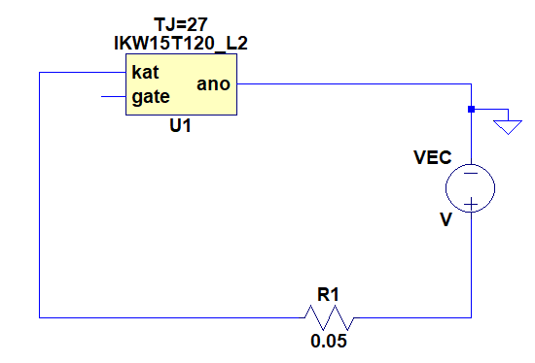

Fig 12 Simulation model 2

1. Forward characteristics of reverse diode:

# Parameter Setup

# Simulation Results

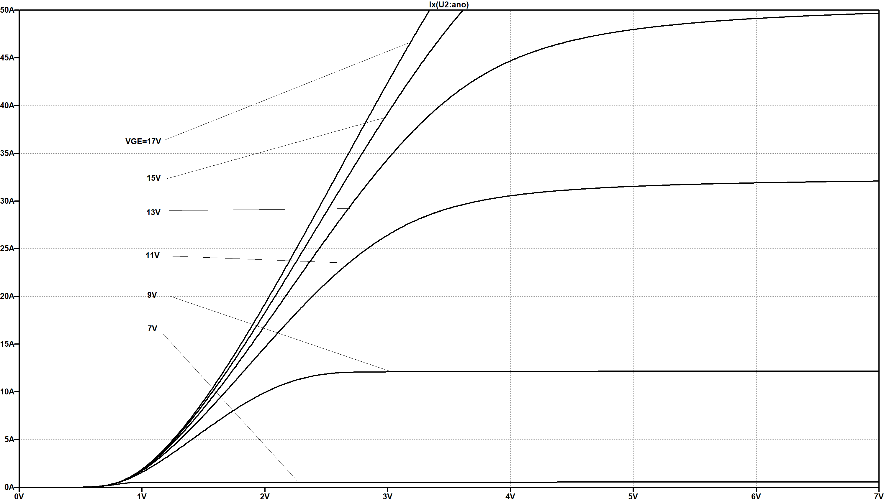

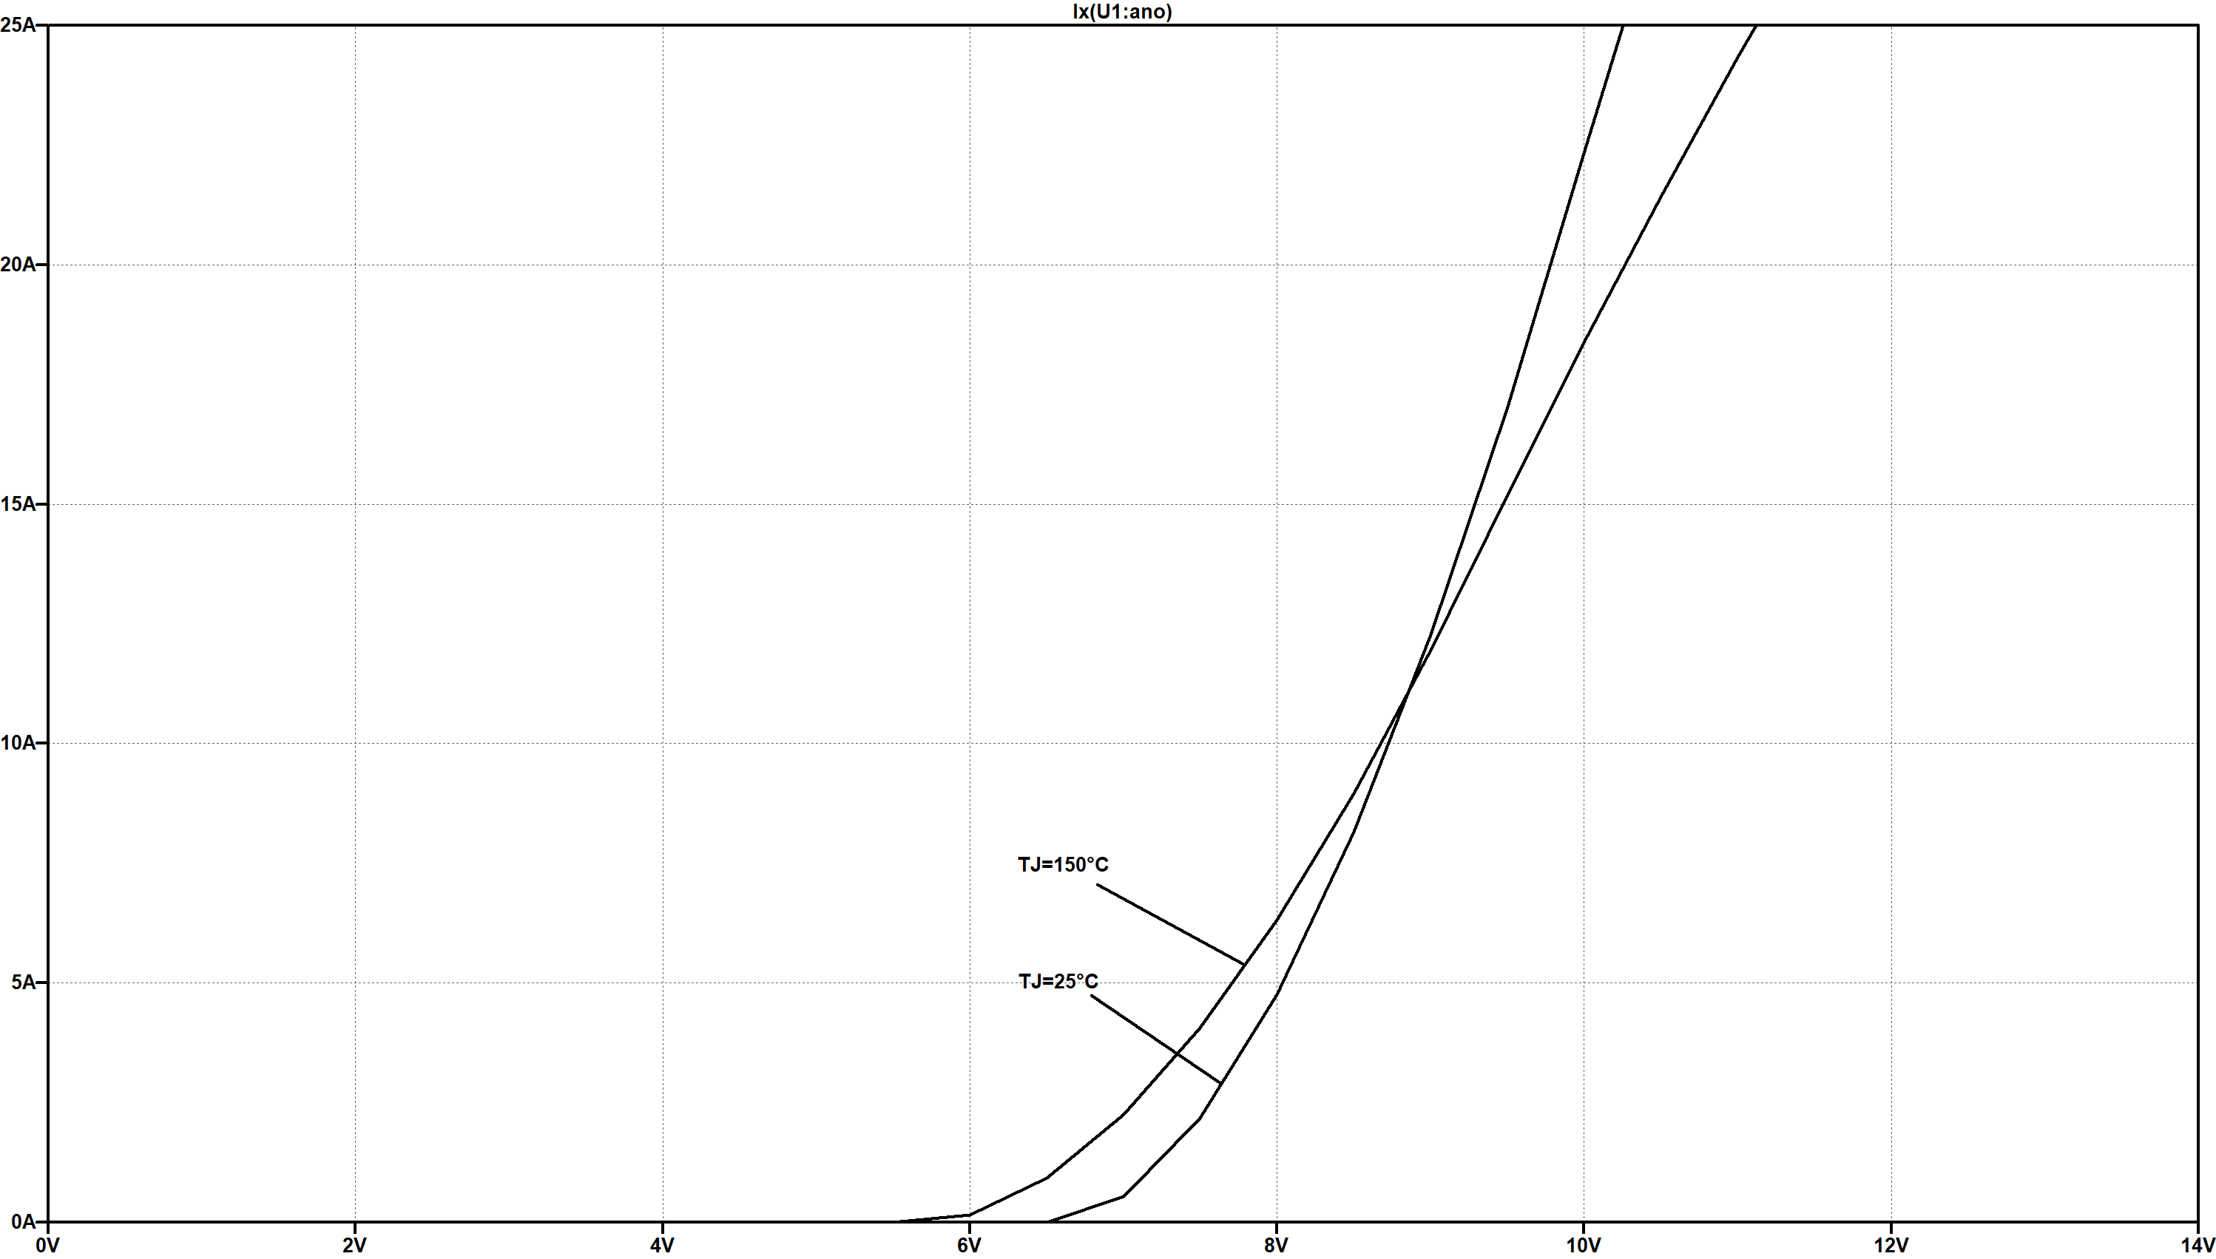

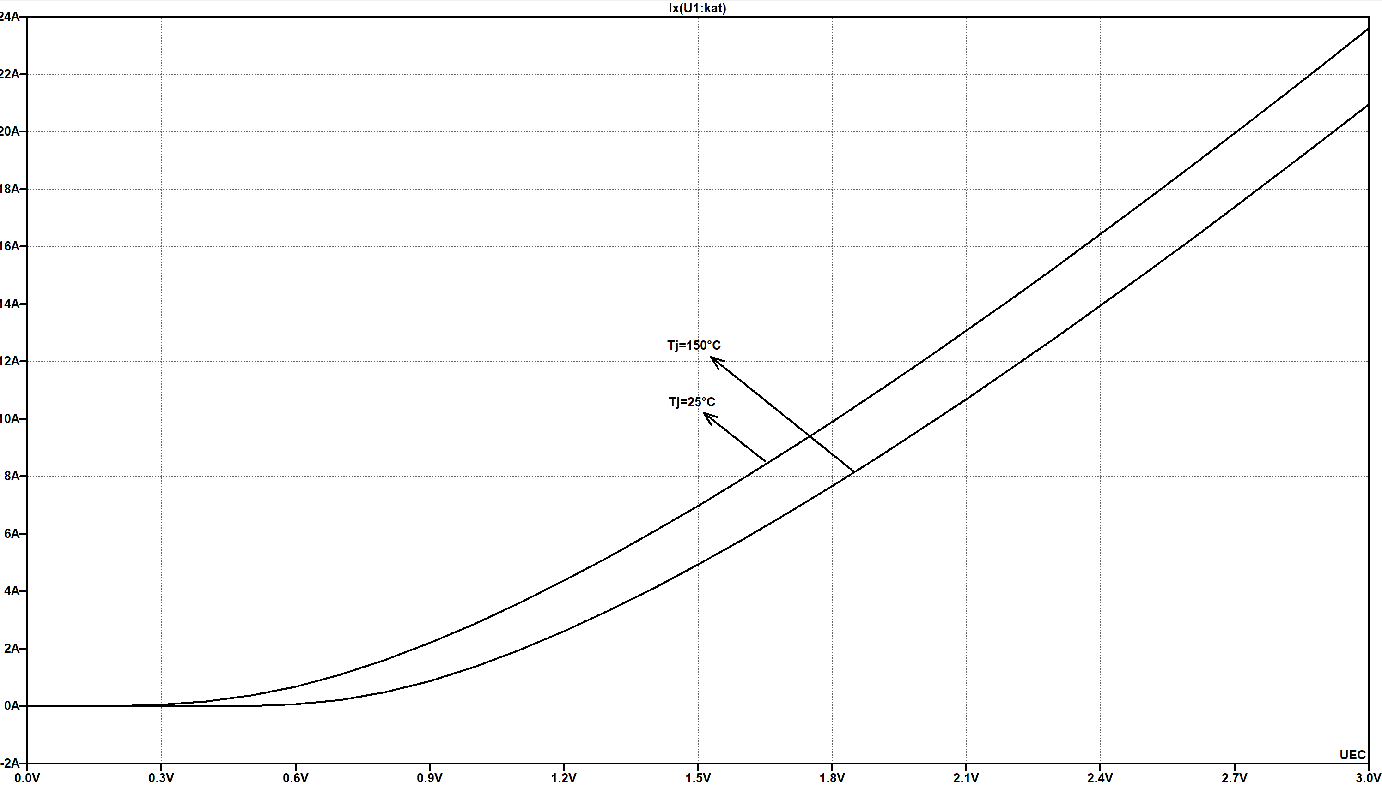

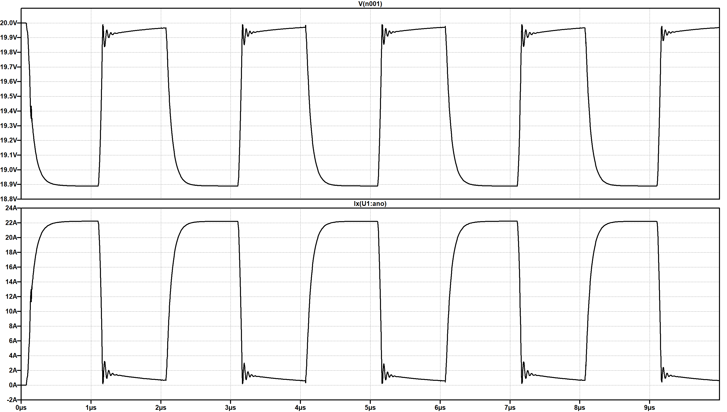

# Analysis of the Results

Tips:

Here is the recommended format of the report: The font used in the report is “Times New Roman”. The title and first-rank title are of size 11, bolded; second-rank titles are of size 11, inclined; and text is of size 10. You can adjust the margin by yourself to make your report neat. When you want to plug in figures, please place it in the center, and the description of the figure should be of size 8.



Figure 1: Logo of XJTU

Your report should include these five parts above. Do these by yourself and discuss with your group member(s) when you have questions.